***SUMMATIVE ASSESSMENT ACTIVITY 1: KNOWLEDGE ASSESSMENT***

1. Identify and list the 10 steps in the accounting cycle.

* **Analysing Transactions:** Examining source documents to identify and analyse business transactions and events.
* **Journalizing Transactions:** Recording transactions in the general journal using double-entry accounting principles.
* **Posting to Ledger Accounts:** Transferring journal entry information to respective accounts in the general ledger.
* **Preparing a Trial Balance:** Compiling a list of all accounts and their balances to verify that total debits equal total credits.
* **Making Adjusting Entries:** Adjusting certain account balances to reflect accruals, deferrals, depreciation, and other adjustments necessary for accurate financial reporting.
* **Preparing an Adjusted Trial Balance:** Generating a trial balance after adjusting entries to ensure that debits still equal credits.
* **Preparing Financial Statements:** Creating the income statement, statement of retained earnings, balance sheet, and statement of cash flows in a specific order using data from the adjusted trial balance.
* **Journalizing and Posting Closing Entries:** Closing revenue, expense, and dividend accounts to retained earnings, and resetting temporary accounts for the next accounting period.
* **Preparing a Post-Closing Trial Balance:** Compiling a trial balance after closing entries to ensure that all temporary accounts have zero balances and only permanent accounts remain.
* **Making Reversing Entries:** Optionally reversing certain adjusting entries made in the previous period to simplify subsequent accounting processes.

2. Fill in the missing words to explain the role of budgeting and forecasting in the strategic planning process.

Strategic planning is a structuredand co-ordinated approach for developing long-term

Organisational gaols and for developing strategies to accomplish them.

Thebudget process consists of activities that encompass the development, implementation, and

evaluation of a plan for the provision of services and capital assets.

Budgeting is implementing a business plan on pager before any resources are committed to

production: it helps you predict the consequences of an adjustment in your operation before ever

making the adjustment

Budgets are usually compiled and re-evaluated on a periodic basis. A budget is a tool that managers use to translate future plans into quantitative terms

3. Explain the following accounting concepts applied in the financial management of a unit.

**Going Concern:** Accountants assume, unless there is evidence to the contrary, that a company is not going broke.

This has important implications for the valuation of assets and liabilities.

**Consistency:** Transactions and valuation methods are treated the same way from year to year, or period to

period. Users of accounts can, therefore, make more meaningful comparisons of financial

performance from year to year. Where accounting policies are changed, companies are required

to disclose this fact and explain the impact of any change.

**Prudence:** Profits are not recognised until a sale has been completed. Also, a cautious view is taken for

future problems and costs of the business (they are "provided for" in the accounts" as soon as

there is a reasonable chance that such costs will be incurred in the future.

4. Explain the following key characteristics of accounting information applied in the financial management of a unit with examples.

|  |  |
| --- | --- |
| Criteria | What it means for the preparation of accounting information |
| Understandability | This implies the expression, with clarity, of accounting information in such a way that it will be  understandable to users - who are assumed to have a reasonable knowledge of business and  economic activities |
| Relevance | This implies that to be useful, accounting information must assist a user to form, confirm or maybe  revise a view - usually in the context of deciding (e.g., should I invest, should I lend money  to this business? Should I work for this business?) |
| Consistency | This implies consistent treatment of similar items and application of accounting policies |
| Comparability | This implies the ability for users to be able to compare similar companies in the same industry  group and to make comparisons of performance over time. Much of the work that goes into  setting accounting standards is based on the need for comparability. |
| Reliability | This implies that the accounting information that is presented is truthful, accurate, complete  (nothing significant missed out) and capable of being verified (e.g., by a potential investor). |
| Objectivity | This implies that accounting information is prepared and reported in a "neutral" way. In other  words, it is not biased towards a particular user group or vested interest |

5. Identify and list the 4 financial reports that would be published in an organization.

* **Income Statement (or Statement of Comprehensive Income):** This report shows the revenues, expenses, gains, and losses over a specific period, typically a fiscal quarter or year. It provides information on the profitability of the organization.
* **Statement of Retained Earnings:** This statement details the changes in retained earnings over the reporting period. It shows how net income, dividends, and other adjustments affect the retained earnings balance.
* **Balance Sheet (or Statement of Financial Position):** This report provides a snapshot of the organization's financial position at a specific point in time. It lists the company's assets, liabilities, and shareholders' equity.
* **Statement of Cash Flows:** This statement presents the cash inflows and outflows from operating, investing, and financing activities during the reporting period. It provides insights into the organization's liquidity and cash management.

6. Identify and list the ratios that are applied to measure the return of an entity.

* **Return on Assets before Interest and Tax:** This ratio measures the net profit generated by the company before interest and taxes relative to its total assets. It indicates how efficiently the company is utilizing its assets to generate profit.
* **Return on Equity (ROE**): ROE measures the profitability of the company from the perspective of its ordinary shareholders. It indicates how much profit is generated for each unit of shareholder's equity.
* **Return on Capital Employed:** ROCE evaluates the return earned by the company on the capital invested by both shareholders and long-term creditors. It assesses the profitability of the company's capital investments.
* **Return on Net Worth:** This ratio evaluates the rate of return on the investment made by the stockholders. It provides insights into the profitability of the company's net assets.

7. Describe the difference between finance (financial analysis) and accounting.

**Finance** involves the strategic management of financial resources to achieve organizational objectives, including activities such as financial planning, capital raising, investment analysis, and risk management. It is closely intertwined with economics and other disciplines.

**Accounting**, on the other hand, is primarily concerned with systematically recording, summarizing, and interpreting financial transactions. It provides the language of business through financial statements and reports, which are essential for decision-making and performance evaluation.

8. Describe the relationship between the financial statements and the accounting equation.

The relationship between the financial statements and the accounting equation ensures accurate recording and reporting. The accounting equation guides transaction recording by maintaining balance, while the financial statements, derived from it, reflect the company's financial position and performance.

9. Describe how you would do a financial analysis (refer to trends and ratios).

1. **Purpose Identification:** Begin by establishing the purpose of the financial analysis. Determine the specific objectives and questions that need to be addressed through the analysis. This could include assessing overall financial performance, identifying areas of strength or weakness, or evaluating profitability and liquidity.
2. **Selection of Tools:** Once the purpose is established, select appropriate tools for the analysis. This may involve choosing relevant financial ratios and trend analysis techniques based on the objectives identified in the first step. Consider factors such as profitability, liquidity, efficiency, and leverage ratios to gain comprehensive insights into the company's financial health.
3. **Comparison:** Compare the financial ratios and trends with relevant benchmarks or standards. This could include comparing the company's performance with industry averages, historical data from previous periods, or established targets and goals. Use this comparison to identify areas where the company is performing well and areas that may require improvement.
4. **Evaluation:** Evaluate the results of the analysis to interpret their significance. Determine whether the observed trends and ratios align with expectations and industry norms. Identify any anomalies or deviations that may require further investigation. Assess the overall financial health of the company based on the analysis conducted.
5. **Prediction and Action:** Based on the findings of the analysis, make predictions about future financial performance, and consider potential actions or strategies to address any identified issues or capitalize on strengths. This could involve adjusting financial plans, implementing cost-saving measures, or investing in growth opportunities.

10. Use an example to describe how you would analyse past performance, recognise opportunities and plan for the future.

Past performance analysis involves reviewing financial statements and trends to assess profitability, liquidity, and efficiency. Opportunities are identified by studying market trends and customer feedback to identify growth opportunities. Future planning includes developing strategic plans, allocating resources wisely, and mitigating risks to achieve long-term objectives.

11. Define financial performance measurement and list at least 3 techniques / ratios that you can use to measure financial performance.

Financial performance measurement involves assessing how effectively a company uses its resources to generate profits and value. Three common techniques for measuring financial performance are:

**1. Return on Investment (ROI):** Measure’s profitability relative to investment cost.

**2. Profitability Ratios:** Evaluate the company's ability to generate profits from operations and assets.

**3. Liquidity Ratios:** Assess the company's ability to meet short-term financial obligations.

***SUMMATIVE ASSESSMENT ACTIVITY 2: KNOWLEDGE ASSESSMENT***

1. Data collected, and calculations can be represented in a graphical format – identify and list at least 4 graph formats

Line Graphs

* Bar Charts
* Pie Charts
* Scatter Plots

2. Identify and list 2 methods each for collecting, organising and analysing financial and economic data.

Observation

* Questionnaires
* Observation

Organisation:

* Spreadsheet software (e.g., Excel)
* Database management systems

Analysis:

* Ratio analysis
* Trend analysis

3. Define averages, standard deviations and line of best fit.

* **Averages:** Statistical measures representing the typical value of a dataset.
* **Standard Deviations:** Statistical measures indicating the dispersion or variability of data points.
* **Line of Best Fit:** A straight line that best represents the relationship between variables in a scatter plot.

4. Describe what “Time value of money” is.

Time value of money refers to the concept that a certain amount of money today is worth more than the same amount in the future due to its potential earning capacity or purchasing power.

***SUMMATIVE ASSESSMENT ACTIVITY 3: PRACTICAL ASSESSMENT***

1. **Provide a recent example of each of the following financial reports** that have been published by an organisation:

1. Statement of Comprehensive Income (income statement)

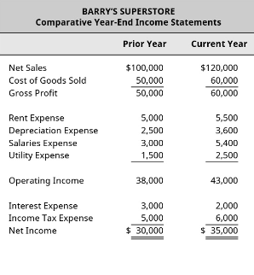

1. Statement of Financial Position (balance sheet)

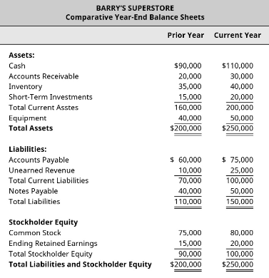

1. Statement of Cashflow

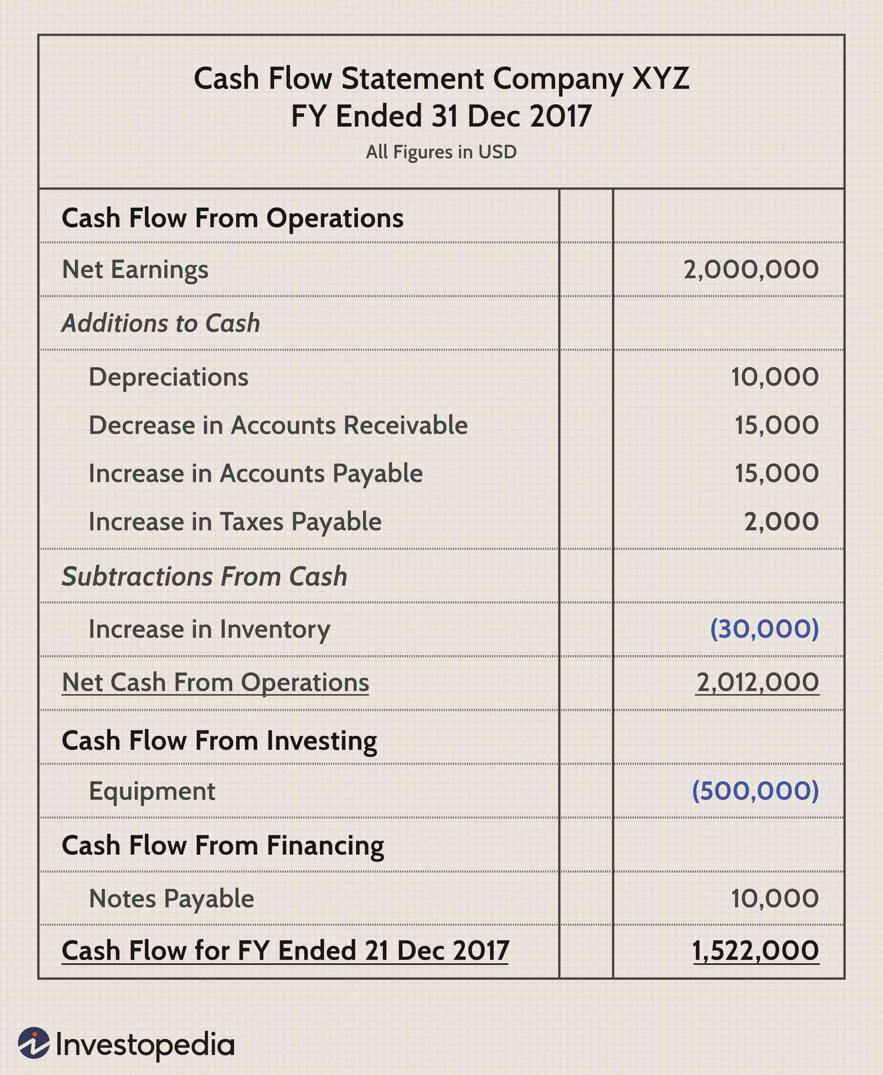

2. Apply mathematical analysis to the economic and financial information by interpreting the selected financial statements:

a. Complete the **income and expenditure statement** summary provided below by filling in figures from the Statement of Comprehensive Income you supplied in 1:

**Company Name: African Resonance.**

INCOME AND EXPENDITURE STATEMENT FOR THE YEAR ENDED December 31, 2023

|  |  |  |  |  |  |
| --- | --- | --- | --- | --- | --- |
|  |  | **This Year:** | **Prior Year:** |  |  |
| **Sales** |  | 120 000 | 100 000 |  |  |
| **Less: Cost of Sales** |  | 60 000 | 50 000 |  |  |
| **Gross profit** |  | 60 000 | 50 000 |  |  |
| **Less:** |  |  |  |  |  |
| **Rent Expense** |  | 5 500 | 5 000 |  |  |
| **Depreciation Expense** |  | 3 600 | 2 500 |  |  |
| **Salary Expense** |  | 5 400 | 3 000 |  |  |
| **Net Profit** |  | 45,500 | 39,500 |  |  |

b. Analysis:

I. Sales increased by R20,000 (20%) from the prior year, leading to a higher profit.

II. Cost of Sales also increased by R10,000 (20%), potentially due to increased production or material costs.

III. Gross Profit increased by R10,000 (20%) due to higher sales and maintained margins.

IV. Running costs increased by R5,500 (20%) from the prior year, possibly due to increased operational expenses.

V. Net Profit increased by R6,000 (15.19%) from the prior year.

**c.** Refer to the **Statement of Financial Position (balance sheet) *that you have supplied and supply the following*:**

|  |  |  |
| --- | --- | --- |
|  | Current year | Prior Year |
| I. Total assets | R 250 000 | R200 000 |
| ii. Total liabilities | R150 000 | R110 000 |
| iii. Stock | R 40 000 | R35 000 |
| iv. Cash and bank balances | R 20 000 | R15 000 |

**d.** Make an assessment of the company’s liquidity based on the Statement of Financial Position (balance sheet) information ***that you have supplied and supply the following*** by completing the following:

|  |  |
| --- | --- |
| I. Calculate the Current Ratio (CR) | **CR = Current Assets/ Current liabilities**  Prior Year = 160 000 / 70 000 = 2.29:1  Current Year = 200 000 / 100 000 = 2:1 |
| ii. What does the CR tell you about the company’s  liquidity? | The Current Ratio (CR) indicates the company's ability to cover its short-term liabilities with its current assets. A higher CR suggests better liquidity. Both years' CRs are above 1, indicating that the company has more than enough current assets to cover its current liabilities. The company's liquidity position has remained strong between the two years. |
| iii. Calculate the Quick Ratio (QR) | **QR = (Current Assets - Inventory) / Current Liabilities**  Prior Year = (160 000 -35 000)/70 000 = 1.79:1  Current Year = (200 000-40 000)/100 000=1.60:1 |
| iv. What does the QR tell you about the company’s  liquidity? | The Quick Ratio (QR) provides insight into the company's liquidity by excluding inventory from current assets. Like the CR, a higher QR suggests better liquidity. Both years' QRs are above 1, indicating that the company has sufficient liquid assets to cover its short-term liabilities, even when excluding inventory. |

e. Indicate economic relationships through graphical representation techniques – use at least 2 and submit all the documents that you used to do this [Note: Graphical formats could include histograms, pie charts, bar charts, line graphs and stack bar charts]

**Bar Chart: Liquidity Ratios**

**Pie Chart: Expense Distribution**

This chart will show the distribution of expenses across different categories for both the current year and the prior year.

1. Review the budget you supplied and highlight the items that are critical to achieving the operational plan of the unit

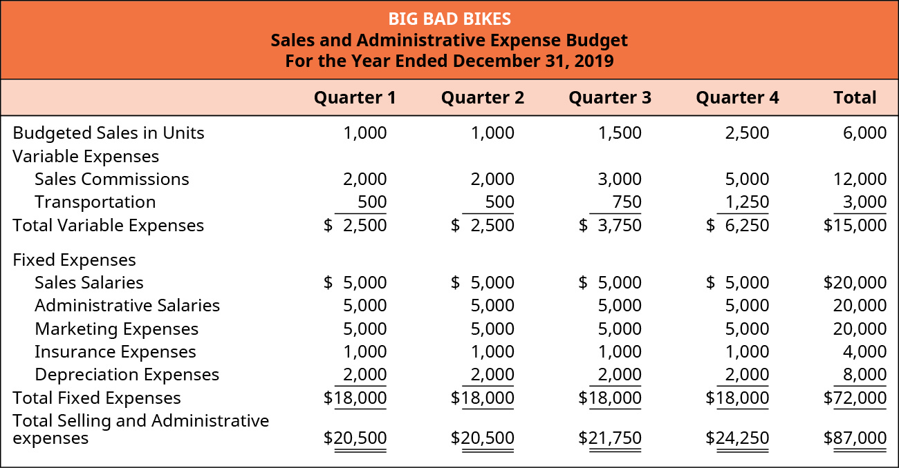

The critical items to achieving the operational plan of the company in the Big Bad Bikes sales and administrative expenses budget for the year ended December 31st, 2019 are:

* **Sales commissions:** This is a variable cost that increases as the number of units sold increases. Sales commissions are a performance-based incentive for the sales team and are critical to motivating them to sell more bikes.
* **Sales salaries:** This is a fixed cost that does not change with the number of units sold. Sales salaries are the wages paid to the sales staff and are critical to staffing the sales team.
* **Marketing expenses:** This is a fixed cost that is used to promote the Big Bad Bikes brand and products. Marketing expenses are critical to generating brand awareness and sales leads.

These items are critical to achieving the operational plan of the unit because they are directly related to the unit's sales goals. Sales commissions motivate the sales team to sell more bikes, sales salaries staff the sales team, and marketing expenses generate brand awareness and sales leads.

It is important to note that all the items in the budget are important to the overall success of the unit. However, the items listed above are the most critical to achieving the unit's sales goals.

1. **Meeting Minutes**

**Meeting Details:**

* **Date:** February 27, 2024
* **Time:** 11:30 AM - 12:30 PM
* **Location:** Lion Boardroom

**Attendees:**

* Lufuno (Software Developer)
* Zanele (System Analyst)
* Phumeza (Software Tester)
* Shelly (Software Developer)
* Philasande Bhani

**Agenda:**

1. Review budget for ENG Unit

**Discussion Points:**

**Budget Review:**

* Lufuno presented the annual budget summary for the ENG Unit.
* The team examined each line item under "General Resources" (ACE ENG, BIG ENG, CIF ENG, FAF ENG, FLP ENG, GAG ENG).

**Key Discussion Points:**

* **ACE ENG:** Phumeza questioned the possibility of utilizing this budget for additional testing tools.
* **BIG ENG:** Shelly sought clarification on the increased allocation for BIG ENG.
* **FLP ENG:** Zanele expressed concern over the negative balance in FLP ENG and requested clarification.

**Challenges:**

* Limited details in the budget summary hindered understanding of each item's purpose.

**Next Steps:**

* Lufuno to provide a detailed breakdown of each "General Resources" budget line item.
* The team will reconvene after receiving additional information for further discussion and potential adjustments.

**Action Items:**

1. **Action Item:**
   * **Owner:** Lufuno (Software Developer)
   * **Due Date:** March 3, 2024
   * **Task:** Obtain and share detailed breakdown of each "General Resources" budget line item.
2. **Action Item:**
   * **Owner:** All Attendees
   * **Due Date:** After receiving additional information (March 3, 2024)
   * **Task:** Review revised budget details and prepare questions or suggestions for discussion.

**Additional Notes:**

* All attendees were present, including Philasande Bhani.
* Limited details in initial budget summary constrained discussion.
* A detailed breakdown of the budget will facilitate a more informed discussion in the next meeting.

**Meeting Recorder:** Philasande Bhani  
**Approved By:** System Analyst